November 3, 2015 Newsletter
Regular Noon Meeting
Ron Brohammer, President called the meeting to order at 12:15 PM at the Shirkey Golf Club.
The Song: Ron Brohammer
The Pledge: Chris Brown The Invocation: Jeremy Blevins
We greeted each other.
Mac Proffitt did the Sergeant at Arms report: Bill and Barb took 210 discarded library books from the Ray County Library to school classrooms at Richmond and Hardin-Central, as well as Ideal Industries. The books were separated by grades from 3-12. Sara took books back to the High School students at Hardin, and Jill took books back to the High School students at Richmond. The books will be added to classroom libraries for student use.
We received a thank you note from a boy who had attended Boy's State and had a good time. We received a thank you note from Beth Gibson for the Installation of Officers Banquet. We have a new Kiwanis Flag from the Lexington Club.
Chris Brown and Jim Rippy received 15 year pins.
Old Business:
Key Club meets the 2nd and 4th Wednesday at 7:10 AM.
Trick-or-Treat Street was a success. We cooked and served 750 hot dogs. Linda took 250 back to the museum and put them in her freezer. We can use them for the Chili/Soup Dinner. We are also saving ketchup and mustard for the Chili Dinner. Sonic donated the hotdog buns and wrappers. Some buns were returned to Sonic. Caseys donated napkins. Shirkeys donated the hotdogs. The ice came from Letzig's and the Eagleton Center. Wal-mart donated the drinks. The Police Department donated the left over soda and candy to the Backpack Program.
Ron will send Thank You notes to businesses thanking them for their support. Barb took several pictures to pass on to Sara to help with an article for the Kiwanis Magazine.
Several people wrote notes on the event to save for next year. They will be printed and kept with the minutes for next year.
Bruce was presented with an official chef's hat.
The Farris Fund Raiser will be this Saturday, November 7, 2015 at 8:00 PM. Music will be by Brewer and Shipley. Jackson Pence (Jill's son) will be the opening act. Cost is $15.00.
The Dictionary Project, sharing dictionaries with third graders and teaching them how to use them, will take place Tuesday, November 3, 2015 at 2:00 PM at Hardin-Central Elementary. A shipment of books already arrived at Hardin. Carole, Ed, Sara, Bill, and Barb will go to help the students learn to use the books. We are still waiting for the books to arrive for the Richmond students.
New Business:
The Chamber of Commerce Business Expo will be held at the Middle School on Saturday, March 12, 2016. It is a chance for local businesses and organizations to share information about their group. We participated the last two years. Jerry moved that we participate again this year, and Don seconded it. We voted to participate.
The Chili/Soup Luncheon will be held in the new year. Bob Haden and John Richardson will get together, and let us know the date and time. We will place the date on the Chamber-of-Commerce calendar, and hopefully not interfere with any other projects at the same time.
The Program Chair for November is Linda.
Luke Covey won the 50/50.
We recited the six Permanent Objects of Kiwanis.
The meeting was adjourned about 12:40 PM.
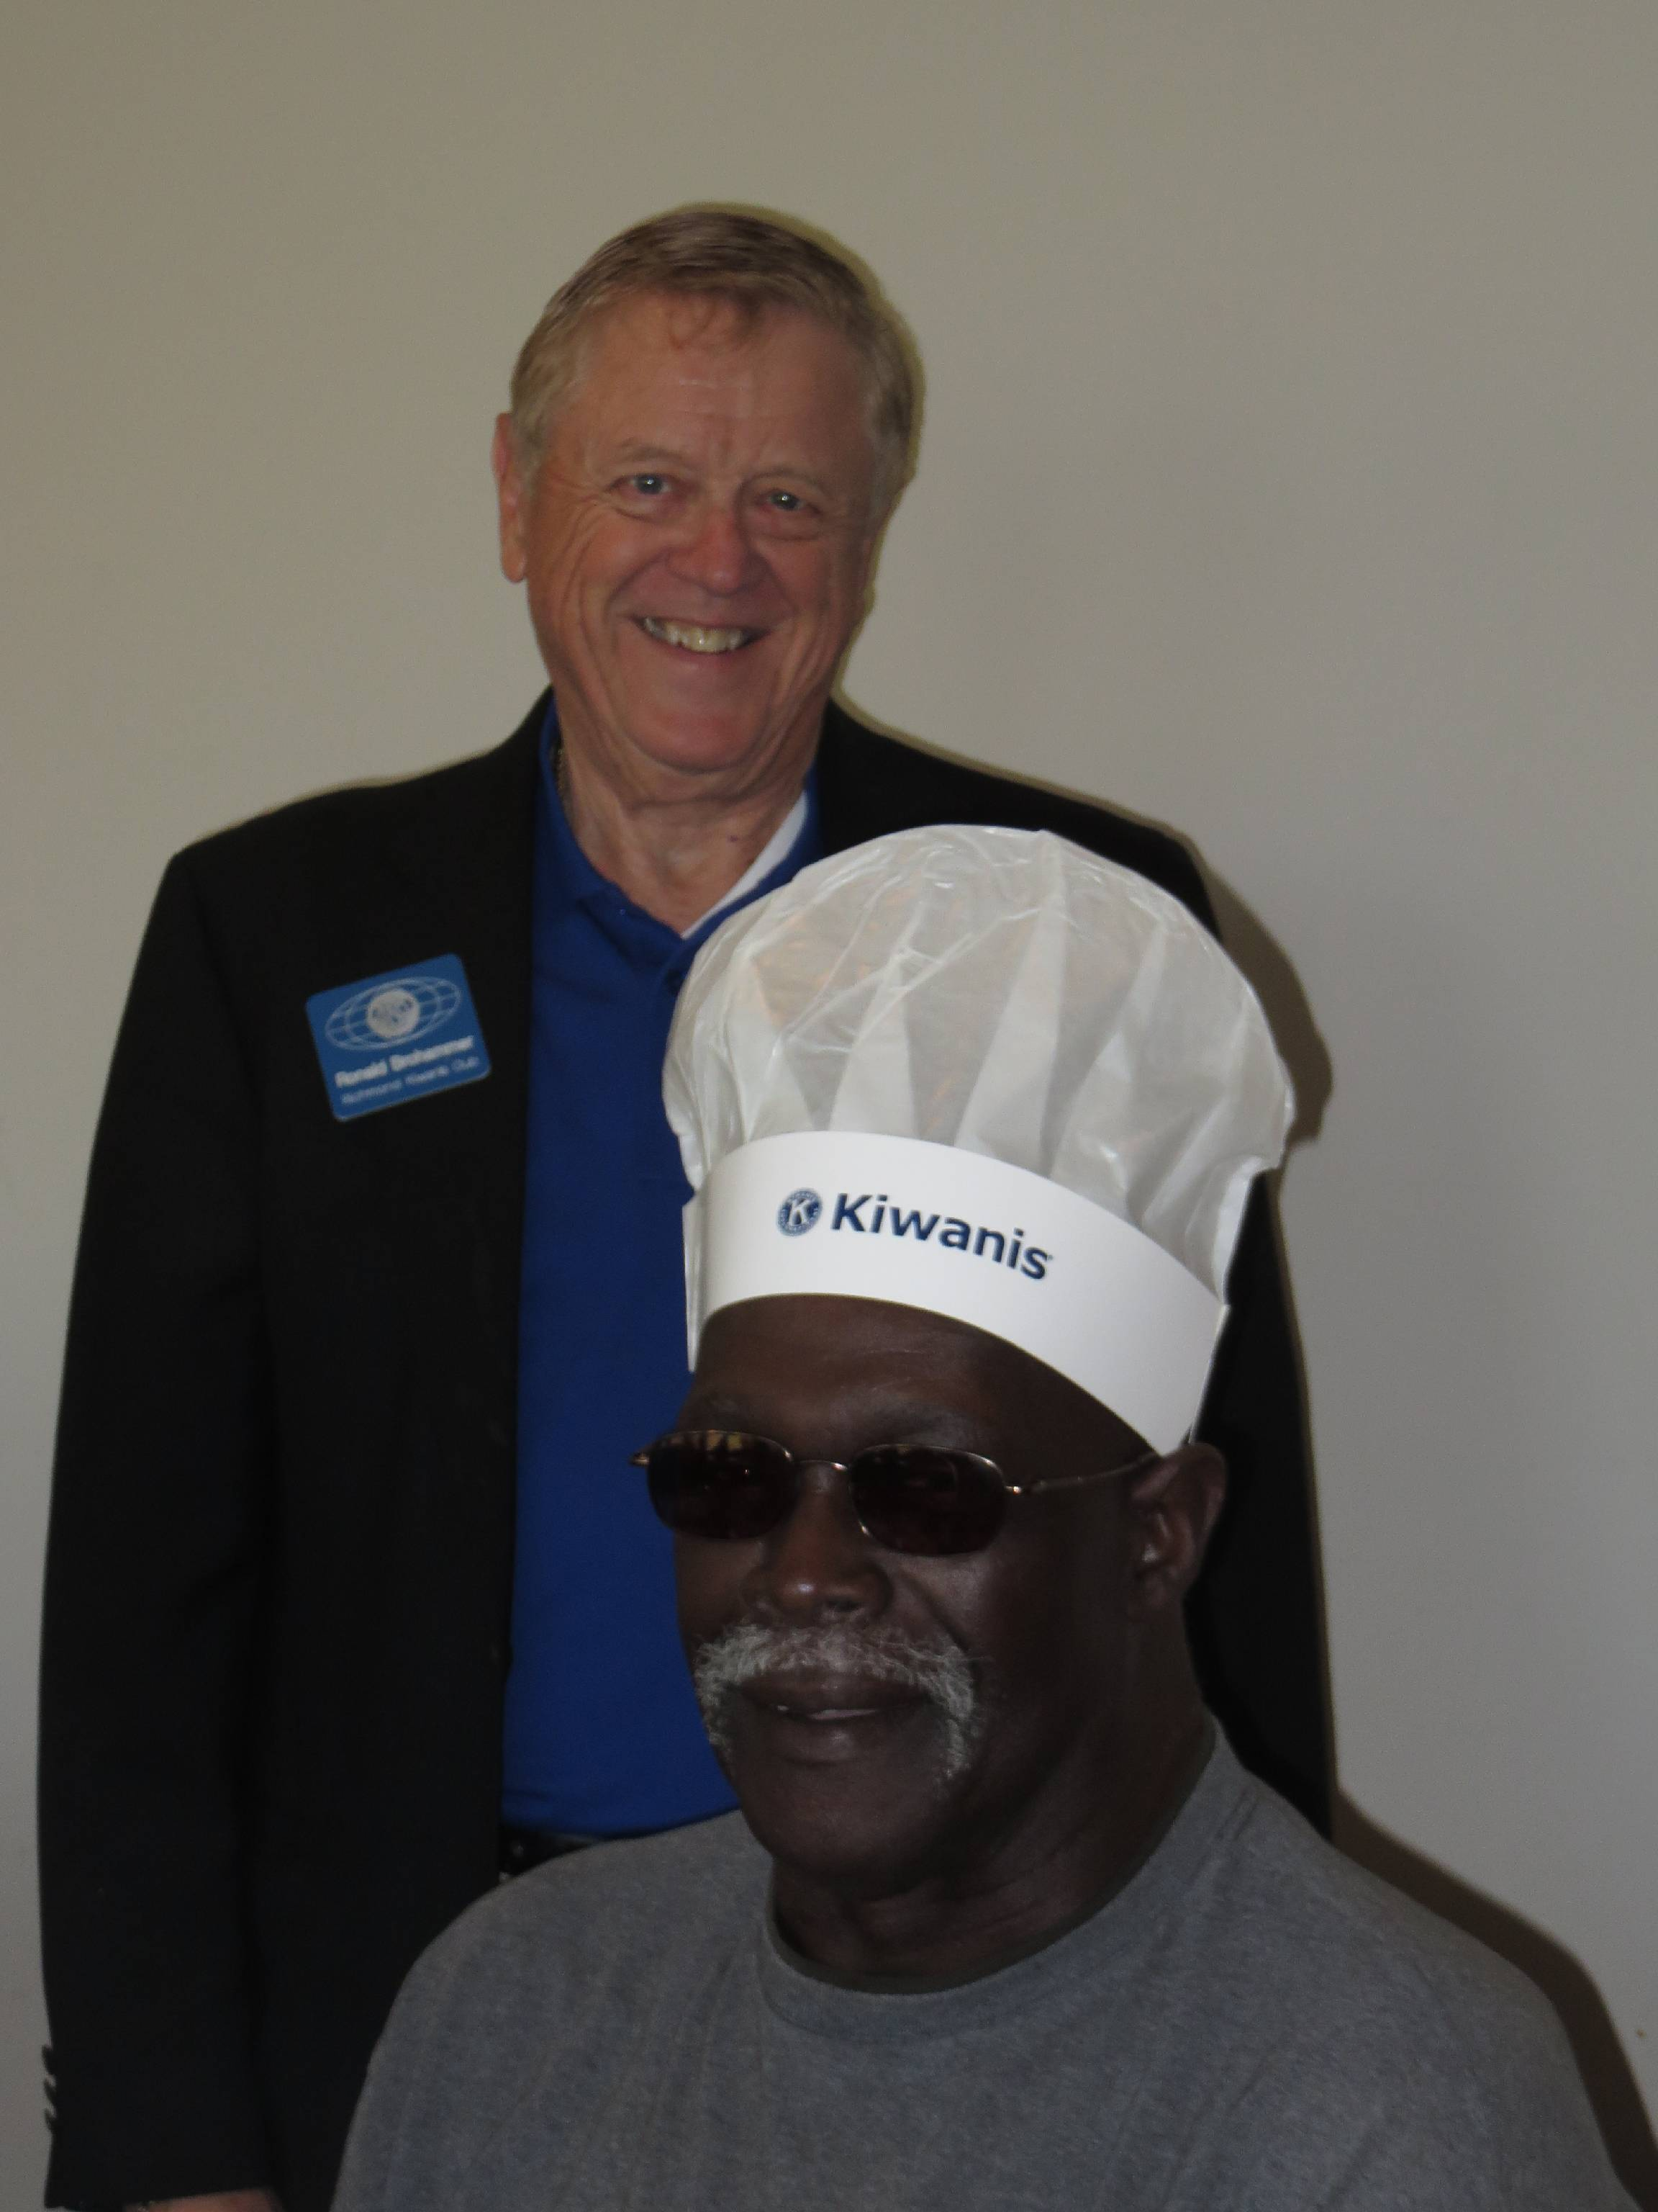

Richmond Kiwanis Club Board Meeting Agenda Date: November 3, 2015
The Board of Directors Re-Convene after closure of regular meeting.
Call to Order at 12:40 PM.
Secretary: Roll Call: Officers: Ron Brohammer; Don Kerrin; Earl Sheehy (absent) Barb Dooley; John Richardson; Directors: Phil Powers; Jo Ellen Dale; Mac Proffitt; Troy Pyle; Lori Baskins (absent); Camille Johnston (absent) There were enough officers and board members present to hold the board meeting.
Minutes of Last Board Meeting: Secretary, Barb Dooley. Minutes were read and approved.
Treasurer: John Richardson
1. Financial Report, John Richardson Administrative account: Started with $7,610.55 Several bills were paid. Balance of $3,900.29.
Service Account: Started with $28,068.18 Several bills were paid. The Balance is $26,051.67 Don moved to accept the report and Mac seconded it. The motion passed.
Committee Reports
1. Executive Committee—Ron Brohammer: No report.
2. Eliminate Project Report—Bill Dooley: No report.
3. Membership Growth Committee—Jerry McCarter: No report.
4. Meeting Programs—Rochelle McCaulley????, not here today
5. Community Service Committee—Sara Seidel: No report.
6. Fundraising—Brian Bush: We are hoping to start working on the Golf Tournament earlier this year. The secret to raising a lot of money is to have a lot of sponsors.
7. Human and Spiritual Values—Phillip Powers, Jeremy Blevins, Jeromy Howard: No report. A card was passed around for Marti to feel better soon.
8. Public Relations—Sara Seidel and Barb Dooley: Lots of pictures were taken at Trick-or-Treat Street. Barb will be sending the best ones to Sara to help in the writing of an article for the Kiwanis Magazine.
9. Young Children / Priority One—Ed Hughes: Bill and Barb have presented Terrific Kid Awards at Sunrise and the Middle School twice. Ed has not given any awards at Dear Elementary yet this year. There will be an assembly coming up, where awards will be given. Dictionaries will be shared with the third graders at Hardin-Central on Tuesday, November 3, 2015 at 2:00 PM. This is known as the Dictionary Project. Sara, Carole, Ed, Bill, and Barb will be there for the lesson on how to use the dictionaries.
10. Inter-Club Events—Don Kerin: There has been a challenge for attending more inter-clubs by the Kiwanis Governor Don Lupold. More information will be coming on that.
11. Sergeant at Arms—Mac Proffitt: No report.
12. Webmaster—Bill Dooley: There is a lot of information on the Website http://richmondkiwanismo.weebly.com Please look it over and let Bill know what you would like to add to it.
Old Business: 1. Bill George Classic Golf Tournament information—Hope to begin planning for this after January 1. Need a Chairperson
2. Richmond Kiwanis Shirts—Interest in a new order? Jerry went in to Ideal Industries and ordered two shirts for $16.00 a piece. They were able to fill the order in a timely manner. Check with them if you need a shirt.
New Business: The Earl Collins Scholarship Foundation has scholarship applications available. They have just come out. Bill will send that information out.
Scholarship Committee: Jill Pence volunteered to serve on this committee. We have a Don Jackson Scholarship and an Elmer Minnick Scholarship that we award every year.
Fire Department: The Fire Department asked for money for educational materials for students. We have $90.00 set aside for it in the budget. Barb moved that we give them $105 for materials. Jill seconded it. The motion passed.
The meeting was adjourned about 1:10 PM.
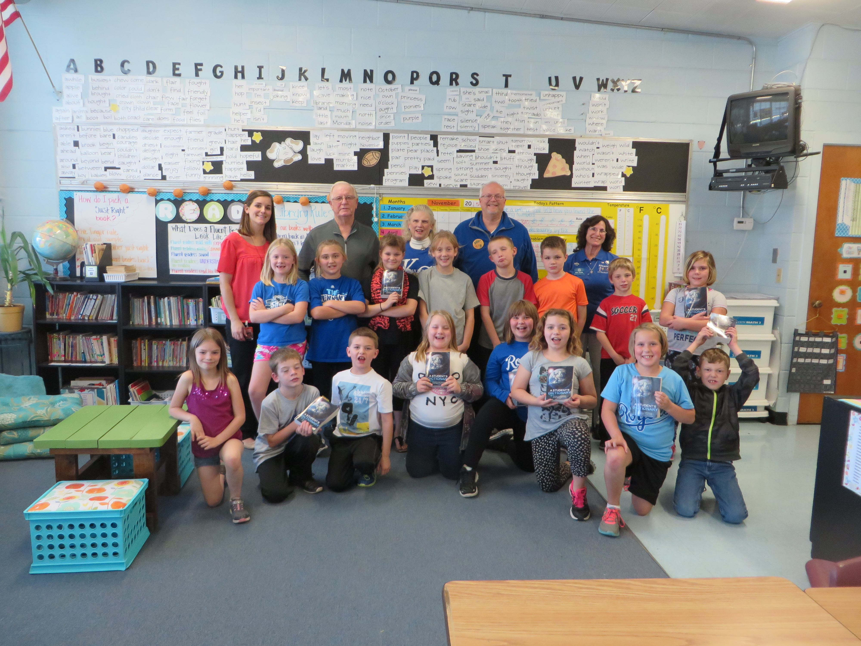
Hardin-Central Third Graders receive their Dictionaries

