March 22, 2016 Newsletter
Regular Noon Meeting
Ron Brohammer, President called the meeting to order at 12:15 PM at the Shirkey Golf Club.
The Song: Bruce Taylor
The Pledge: Barb Dooley The Invocation: Ed Hughes
Members greeted each other. Ron talked about Democracy and told jokes. There were no guests today:
Mac Proffitt did the Sergeant at Arms report: Several dollars were put in for missed meetings and pictures in the paper.
Nate McEuen will perform at the Farris Theater in Richmond, MO on Friday, March 25, 2016. Doors open at 7:00 PM and the concert begins at 8:00 PM. Cost is $12.00 in advance and $15.00 at the door.
Old Business:
Key Club meets the 2nd and 4th Wednesday at 7:10 AM.
Kansas City Royals Tickets Raffle: Chastidy Lofton was the winner, and the letter for the tickets was delivered to her.
Scholarship Committee: No report. Applications have gone out to students. We are now waiting for them to be returned.
Program Chairmen-Chairwomen needed: There is a need for program chairpersons. March: Ron Brohammer; April: Bruce Taylor; May: Earl Sheehy; June: Sara Seidel; July: ________ __________; August: Linda Emley; September: ___________
New Business:
Trivia Night: Moved to the fall.
Golf Tournament: Brian Bush; No date yet. Will meet with his committee in the next couple of weeks and come up with a date. Start thinking about sponsors for the event. They can be local businesses or businesses in other cities. The more sponsors we have, the more profit we will make.
Nominating Committee for Officers for 2016-17: If you are interested in an office for next year, please let Ron know. We need our new slate of officers before the Governor’s Meeting May 21.
Mom’s Day Baby Shower: Sara Seidel moved that we participate in the Kiwanis Mom’s Day Baby Shower. Bob Haden seconded it. We voted, and it passed. Bob Haden moved that we do it on Saturday, April 30, 2016. Bruce Taylor seconded it. We will do it on April 30, 2016 from 9:00 AM- 3:00 PM. We will sit by the doors at Wal-mart.
Kiwanis One Day (usually April 2); Trash Clean-up: Tuesday, May 3, 2016 at 6:00 PM: Meet in the parking lot at the Christian/Presbyterian church at 6:00 PM. Bring yard gloves and grabbers to pick up the trash. Ron will bring the trash bags.
Mushroom Festival: Saturday, May 7, 2016: Terrific Kids Float We can use Steve Meyer’s trailer, and Ed Hughes said we can use his truck. Brian Bush will ask Camille Johnston for some straw (her brother has a horse farm). We will send a letter home to the students in each school building to ride on the float. It will need a signed permission form to ride on the float, times to arrive, etc.
Weather Spotting Program: March 24, 2016; 7:00 PM at the Farris Theater; Everyone is invited to attend the program.
The City of Richmond has 7 sirens in town that will go off for emergencies. The practice is on Wednesday at 11:30 AM. There will be a warning siren. Then the siren will go off for three minutes. If you hear it, it means to take cover for a tornado. It will pause for five minutes, and then go off again for three minutes. There is no “All Clear” at the end.
Ron Brohammer talked a little bit about the Motor Vehicle Sales Tax that will be on the ballot Tuesday, April 5, 2016.
The tax will allow Richmond and other cities to continue to collect sales tax on vehicles that were purchased from a private individual or in another state. If we can collect this tax it will add about $40,000 dollars a year to monies that the city needs to run the city of Richmond. This includes money for the city, streets, parks, and the municipal building. It is not a new tax. It is a continuation of a tax that we have had for many years.
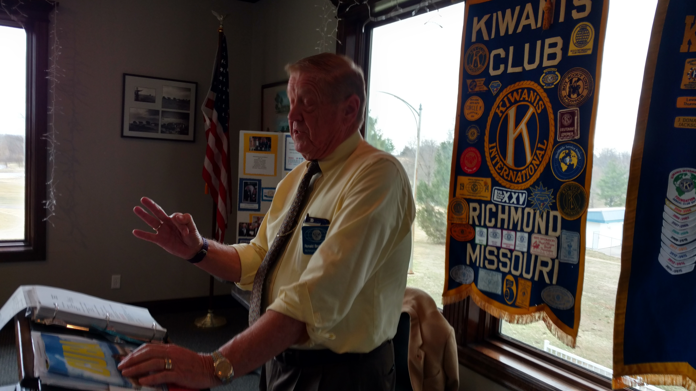
Ron Brohammer
See next page
Drawing for the 50/50: Jerry McCarter
Adjournment: 1:10 PM

Upcoming Events:
March 24, 2016; Thursday: Weather Spotting Program: 7:00 PM at the Farris Theater; Everyone is invited to attend the program.
March 25, 2016; Friday: Nate McEuen will perform at the Farris Theater in Richmond, MO. Doors open at 7:00 PM and the concert begins at 8:00 PM. Cost is $12.00 in advance and $15.00 at the door.
April 5, 2016; Tuesday: Motor Vehicle Sales Tax ; Go to the polls and exercise your right to vote.
April 9, 2016; Saturday: Pancake Breakfast sponsored by Liberty Kiwanis, 8:00 AM- 11:00 AM; $7.00 donation; Discovery Middle School, 800 Midjay Drive, Liberty, MO. Chris Cakes will be “flippin’ & grillin.’” Profits will be used for local scholarships.
April 30, 2016: Saturday: Mom’s Day Baby Shower; 9:00 AM- 3:00 PM; Richmond Wal-Mart doors; working with House of Hope and Department of Family Services
May 3, 2016; Tuesday; Kiwanis One Day (usually on April 2) Trash Clean-up: at 6:00 PM: Meet in the parking lot at the Christian/Presbyterian church at 6:00 PM. Bring yard gloves and grabbers to pick up the trash. Ron will bring the trash bags.
May 7, 2016; Saturday: Terrific Kids Float at the Mushroom Festival
May 21, 2016; Saturday: Region 1 Training and Governor’s visit; American Inn, North Kansas City
June 4, 2016; Saturday: Kiwanis Fishing Day sponsored by Smithville Kiwanis
Barb Dooley, Secretary

