September 15, 2015 Newsletter
John Richardson, President called the meeting to order at 12:15 PM at the Shirkey Golf Club.
The Song: Bill Dooley
The Pledge: Brian Bush
The Invocation: Ron Brohammer
A sheet was passed around for members to write in their e-mail addresses and phone numbers. Sheets were also passed around to sign up for Trivia Night on Sept 19 in North Kansas City and the Installation Banquet on Tuesday, Sept 29 at 6:00 PM, cost $12.00. There was a sign-up sheet to order a Kiwanis hat for $16.00 and a final sheet to sign up for scheduling programs for this next year.
Ron gave a report on having meetings at Shirkey's. He talked to Tim and Kyle. They would like for us to continue having our meetings at Shirkey's. There hasn't been a price increase for five years. They really need to raise the price to cover the cost of the food and the preparation of it. Rotary is going to meet at Jeffery Kyles the next two Fridays. FG moved that we stay at Shirkey's for lunch. Jerry seconded the motion. The vote passed. We will continue to have our weekly meetings at Shirkey's.
Outlaw Days went well this past Saturday. Ron, Barb, Bill, Ed, Sara, and Jimmy Carter were there to help with the Barrel Races. There was only one participant. He ran the race and won. Bill and Barb's grandson ran a shortened version of the race (he is 4) and got a ribbon for participating. He was happy about that.
Jerry did the Sergeant-at-arms report.
Bill shared information about Carrolton's Golf Tournament that was held Monday, Sept 14. They raised over $25,000. Some of their sponsors paid $5,000 for a banner with their name on it. There was a smaller banner for $1,000. They had small signs for $100 like we have. They had 70 participants, 35 teams of two. They served a lunch similar to ours. They plan over a period of nine months.
Jim Rippy talked about businesses in town putting out Spartan signs to support our players on sports teams.
Ron reported that Bruce Taylor is having back surgery on Wednesday, September 16. We will send a card to Get Well Soon.
Sara reported that the Farris Theater board had met. They are challenging organizations in town to send members for "A Night on the Town." The Holiday Brass concert will be on Monday, December 7, 2015.
Bill reported that Jim Gibson, Trustee of Region 1 had invited us to participate in a radio thon. It will be held on Saturday, Oct 31 from 6:00 AM-12:00 noon. We would need to have participants at KMZU, the radio station in Carrolton, to talk about Project Eliminate and raise money. Jerry moved that we participate in the radio thon. Ron seconded it. A vote was taken. The vote failed. We will not participate. We will be getting ready for Trick-or-Treat-Street that will start later that day.
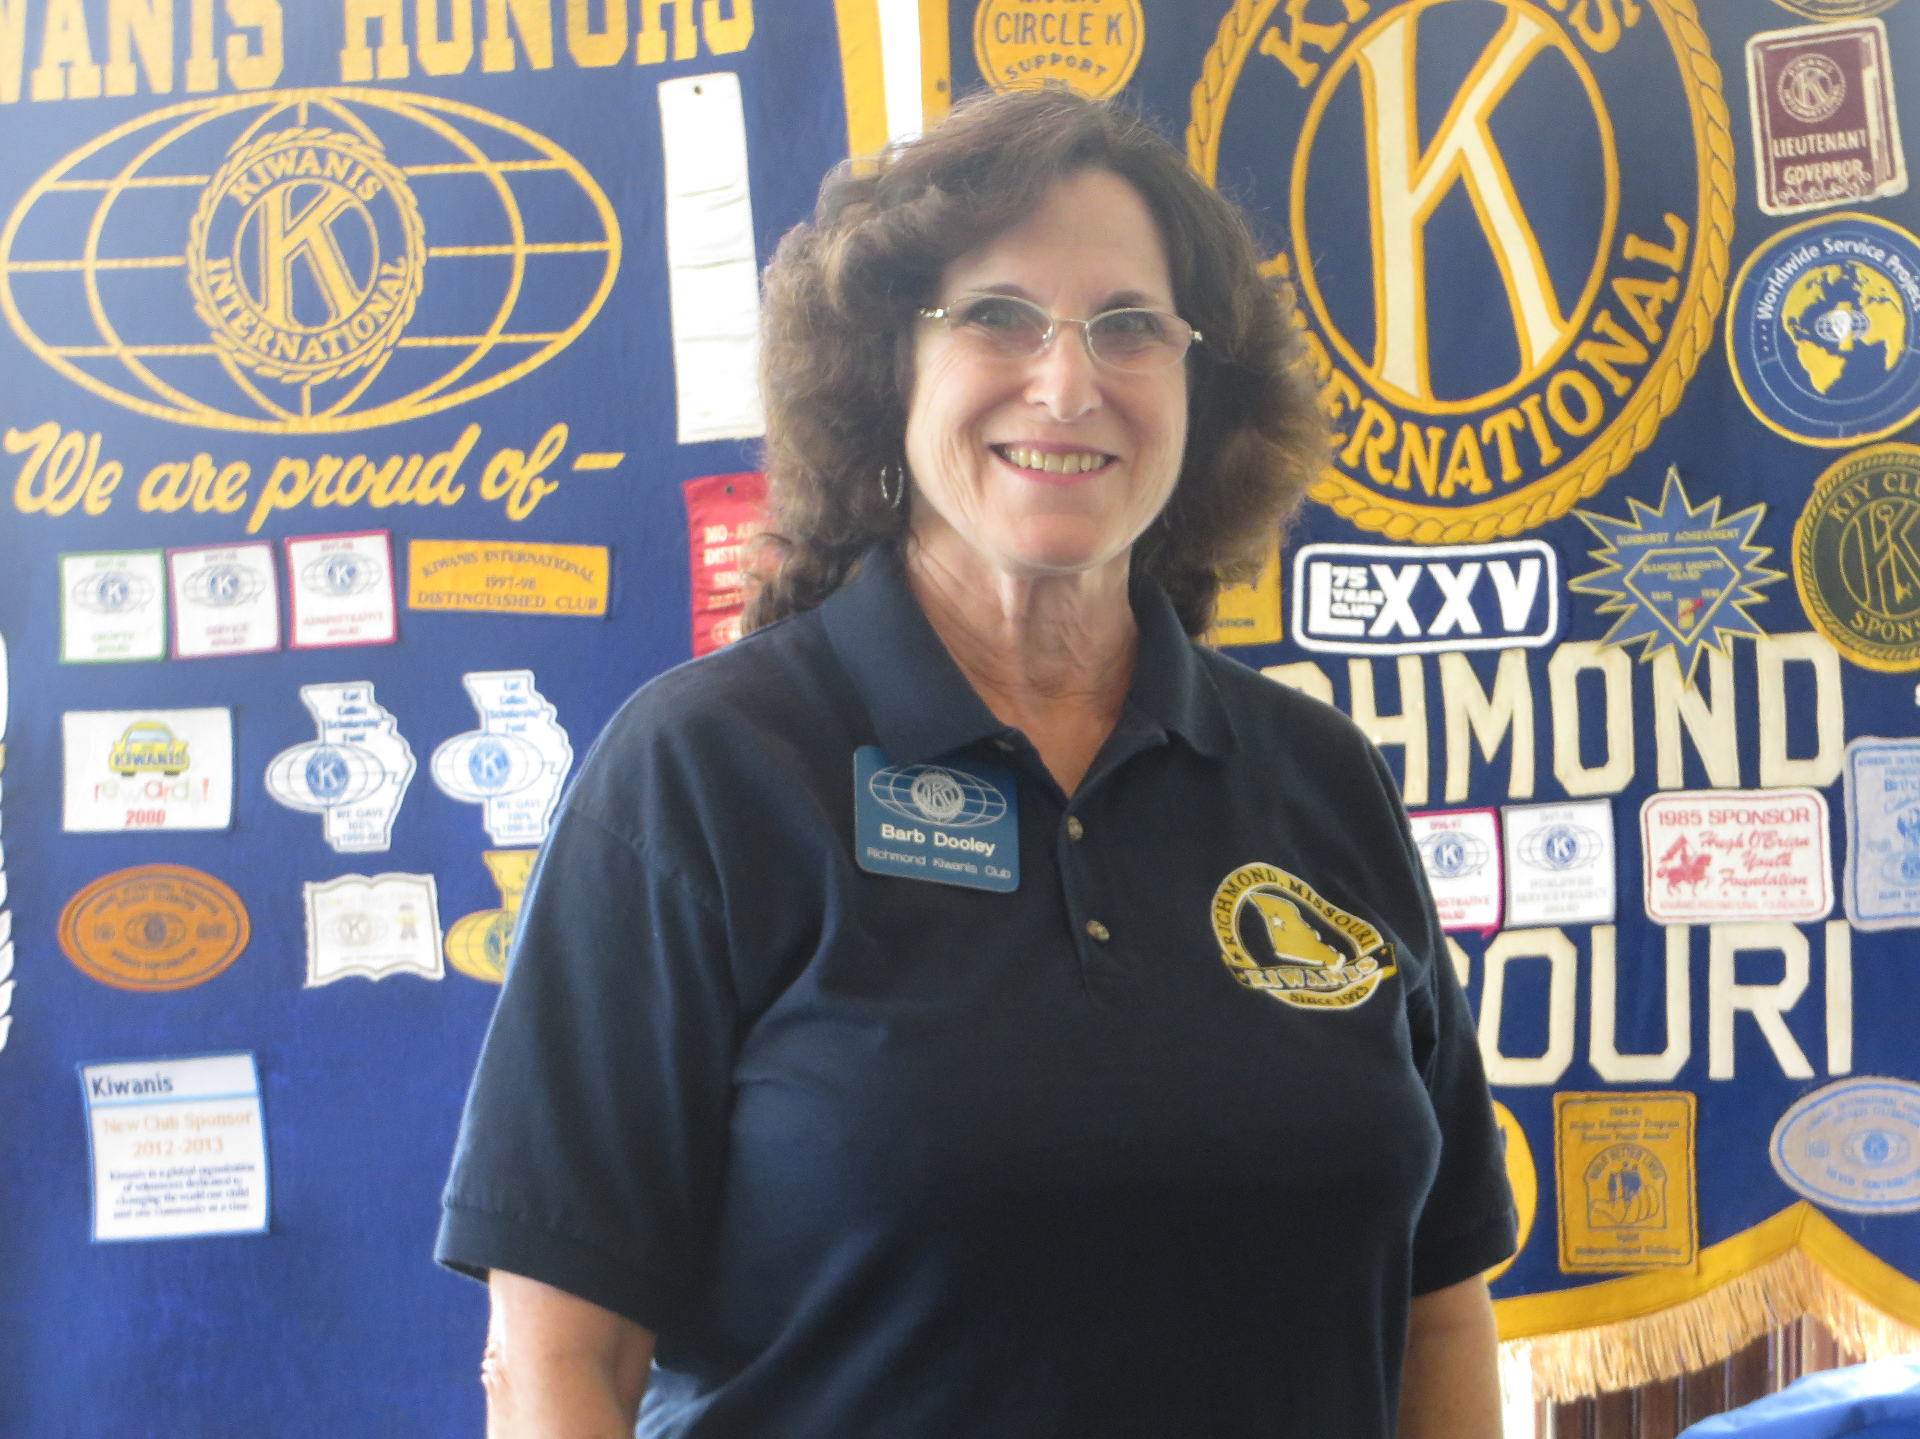
Barb gave a program for Youth Protection Week, Sept 13-19, 2015. It included a power point, a handout, and a set of questions to fill in. Kiwanians interact with more than 300,000 youth each year. Adults working directly with youth will need a background check every ten years. We need to keep the young people safe, as well as ourselves. Chaperones are needed for events and it is a good idea to have more than one. If there is a problem, ask for help from school officials or others. Be mindful of social media, and remember that is public information going out over the web. Most of all, we need to just use common sense.
The meet ing was adjourned by Ron.
There will be no noon meeting on Tuesday, Sept. 29!
Upcoming events:
September 19th: Sat @ 5:30 North KC Trivia Night at the American Inn. We need a team!
September 29th: Tuesday. Richmond Kiwanis Fall Banquet and Installation of Officers for 2015-16. 6:00 pm. Shirkey's 19th Hole. October 31st: Trick-or-Treat Street
See the Richmond Kiwanis Website for more info.

