June 14, 2016 Newsletter
Regular Noon Meeting
Ron Brohammer, President called the meeting to order at 12:15 PM at the Shirkey Golf Club.
The Song: Sara Seidel
The Pledge: Earl Sheehy The Invocation: Jeremy Blevins
There were no jokes today. There was sadness over the recent killings in Orlando, Florida. We are also sad to have lost John Richardson, our Past-President to cancer. He passed away Tuesday morning.
We had two special guests today. Cathy Gotch (Confederate Cathy) came with Linda Emley. Amy Sisson was our guest speaker and she talked about working with her police dog, Vengeance.
Mac Proffitt did the Sergeant at Arms report: People paid a dollar for missing meetings, birthdays, and upcoming trips.
Club Achievements and Announcements: none
Old Business:
Key Club meets the 2nd and 4th Wednesday at 7:10 AM. They will start again in the fall.
Marla Ross from the library will receive this quarter’s Star Award. We are not sure when it will be presented. The lady who does the engraving on the trophy is on vacation. Jim Rippy is working on it.
Program Chairperson: May: Earl Sheehy, June: Sara Seidel: three students are coming to talk about how the schools have helped them now that they are adults; July: Jerry McCarter, August: ______________, September: Chris Brown volunteered to do this.
New Business
Golf Tournament: Brian Bush The date for the Golf Tournament will be Friday, September 9, 2016. Brian has updated all forms and sent them to Barb. She forwarded them to everyone. Bill also added them to our website: richmondkiwanismo.weebly.com, so if you need them, they are easy to access. If you ask a business to be a sponsor, perhaps they would post the information sheet in their window. It would help to get the word out. The cost to play will still be $80.00 each, and we will still go with three man teams.
Don Kerin has an updated sponsor list. Check with him about which businesses to contact for sponsorship. There is an incentive: “The member who brings in the most sponsorship dollars gets five meals at the 19th Hole, courtesy of the club.”
Our Club Brochure has been updated. Thank you Jerry McCarter for your effort on this.
We were sad to hear that John Richardson, our past-president and friend, has lost his battle with cancer. We signed a card for him. Bob Haden will send it with a check to a charity of the family’s choice. A plant or flowers will be sent. (Barb and Bill Dooley ordered a plant to be sent after the meeting.)
Sergeant Amy Sisson, from the Richmond Police Department was our guest speaker today. When asked how Richmond High School impacted her life she shared a story with us. Her father passed away when she was sixteen years old. He was hit by a motor vehicle. Her high school friends became her family and her mentors. She graduated in 2001. She was 4th in her Class, and lettered in four sports.

She has been a member of the Richmond Police Department for the past ten years. They asked her if she would be interested in working with a police dog, and she said yes. The dog and the training cost about $10,000. Vengeance is her new partner. She is about 1 ½ years old and has been trained in narcotics detection and tracking through the North American Police Work Dog Association. She is a German Shepherd and enjoys swimming and nature walks when she is not working.

Drawing for the 50/50: Mac Proffitt won the 50/50.
Adjournment: 12:45 PM
Barb Dooley Secretary

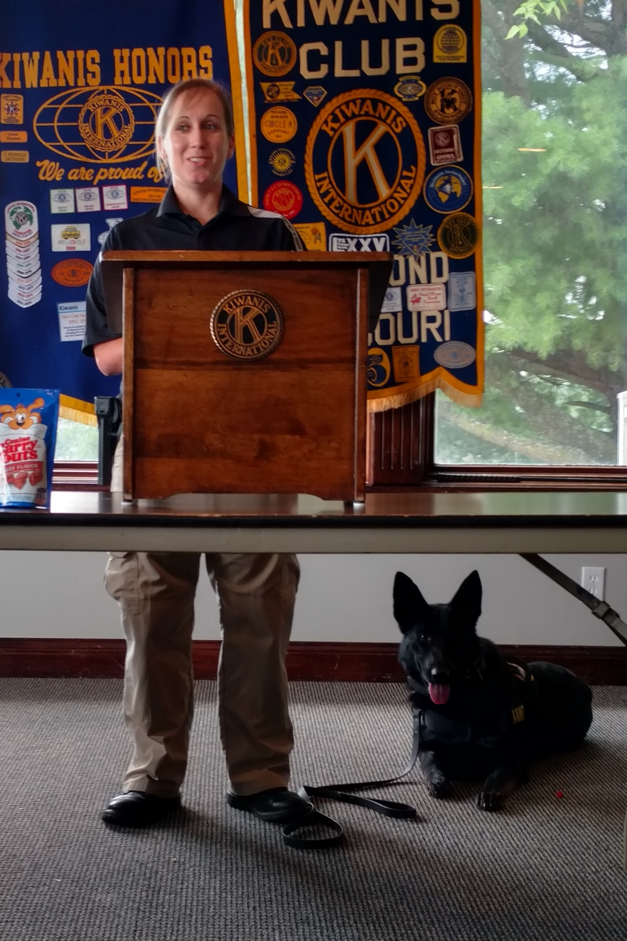
Sgt. Sisson and Vengeance
See next page for upcoming events
Upcoming Events:
June 25-28, 2016: International Conference: Toronto, Canada
August 11-13, 2016: MO/ARK District Convention: North Little Rock, Arkansas
September 9, 2016: Friday: Richmond Golf Tournament: A Charity Benefit for Kiwanis Scholarships and Youth Programs in the Richmond Area
11:00 AM-12:00 Noon: Sign in Registration
11:30 AM-12:00 Noon: Lunch at Clubhouse (included in price of golf)
12:00 Noon: Tee off time, shotgun start
Cost: $80.00 per team member, 3 man scramble, $240 per team
Individual prizes for Longest Drive, Closest to pin, Longest Putt
You are invited to play, be a sponsor, or help out

September 12, 2016: Monday: Carrolton Golf Tournament; 2 man scramble

