December 15, 2015 Newsletter
Regular Noon Meeting
Ron Brohammer, President called the meeting to order at 12:15 PM at the Shirkey Golf Club.
The Song: Bill Dooley
The Pledge: Sara Seidel The Invocation: Chris Brown
We greeted each other. Ron told jokes.
Mac Proffitt did the Sergeant at Arms report: Several dollars were put in for missed meetings, upcoming birthdays, and meetings that will be missed in the next few weeks.
Club Achievments/Announcements : The fourth quarter Star Award will be presented to Mike McCalley next Tuesday, Dec 22, 2015.
There will be no meeting on Tuesday, December 29, 2015.
Old Business:
Key Club meets the 2nd and 4th Wednesday at 7:10 AM. Josh will talk to the members about a Trivia Night in the March time frame. We will try to have it at the High School with the cooperation of the Key Club members.
The Farris Fund Raiser, Holiday Brass: Monday, December 7, 2015 at 7:00 PM at the Farris Theater. Kiwanis had 31% of their members in attendance, and we won $100.00 first prize for having the best attendance. Sara Seidel did not have a check to give us yet.
Chili/Soup Luncheon: We will start cooking the meat on Friday evening Feb 12 to be ready for the luncheon on Saturday, February 13, 2016. John Richardson is in charge and head chefs are Bruce Taylor, Troy Pyle, and Brian Bush. Everyone should plan to bring a dessert. There will be a sign-up list for other donations.
Bruce Taylor moved to charge $7.00 for a ticket to include: Chili or soup, a hot dog, a beverage, and dessert. The motion was seconded by Chris Brown. The motion passed.
Jimmy Rippy moved to give the police department and the sheriff department five tickets each to share with their staff. Ed Hughes seconded the motion. The motion passed.
Bill Dooley moved that each Kiwanis member be given 5 tickets to sell or give away. The Kiwanian will be responsible for the $35.00 donation to come back to the club. The motion was seconded by Jerry McCarter. The motion passed.
We will need to print about 250 tickets at Tabers. Unsold tickets will be turned back in to the treasurer. Someone paying at the door won’t need a ticket. They will just be able to walk in and eat.
We will need an ad in the Carrolton paper, and another in the Richmond News. Ron asked Sara to write an ad for the papers. We can also send it to KMZU radio. The time will be 11:00 AM to 1:00 PM, or whenever we run out of food. Don Kerinchecked the dates with the church, and we are ok for that date, Feb 13, 2016.
Rochelle McCaulley is working on the place mats. You can place a two line ad for $10.00 and a business card size ad for $25.00 Please let her know if you are interested in placing an ad. We will print them at Tabers.
Dictionaries: Ed Hughes, Bill Dooley, and Barb Dooley met at Sunrise Elementary Monday, Dec 7, 2015 at 1:30 in the cafeteria. The students were each given a new dictionary. Bill talked about how to use it, and Ed, Barb, Bill, and the teachers moved around the room to help the students find the words in the book. The students did a good job using the books, and were glad to receive them. It was a super afternoon! 123 dictionaries were given out or were saved for students who were absent. We paid the Dictionary Project of Kansas City $200.00 to offset the cost of the dictionaries. The project is now completed until next year.
The Chamber of Commerce Business Expo will be held at the Middle School on Saturday, March 12, 2016. It is a chance for local businesses and organizations to share information about their group. Bill and Ron will chair it. Be thinking if you might want to come and sit for an hour and talk to people about our group.
New Business:
Trivia Night: Bill and Barb have not set up a date for Trivia Night yet. See info listed under Key Club.
Roster: Barb passed around another roster for updating, as we are trying to get a current list of names, emails, and phone numbers.
Program Chair for December: Jerry McCarter
Permanent Objects of Kiwanis: We recited the six permanent Objects of Kiwanis.
Guest Speaker: Richard Roark, Executive Director of 911
The 911 office is located at 102 N W Main Street. Missouri is the only state that does not receive funding for 911 through the State Legislature. As it stands now, each city must pay to support it. They may ask for a local sales tax to help fund it. Right now the city of Richmond pays $156,900 per year for the service.
Continued on next page
Fourteen people are employed there. They work 12 hour shifts, with two people on each shift. People will soon be able to text to 911. That will help with domestic calls.
Ray County is consolidated with all of the calls in the county coming in to one dispatcher.

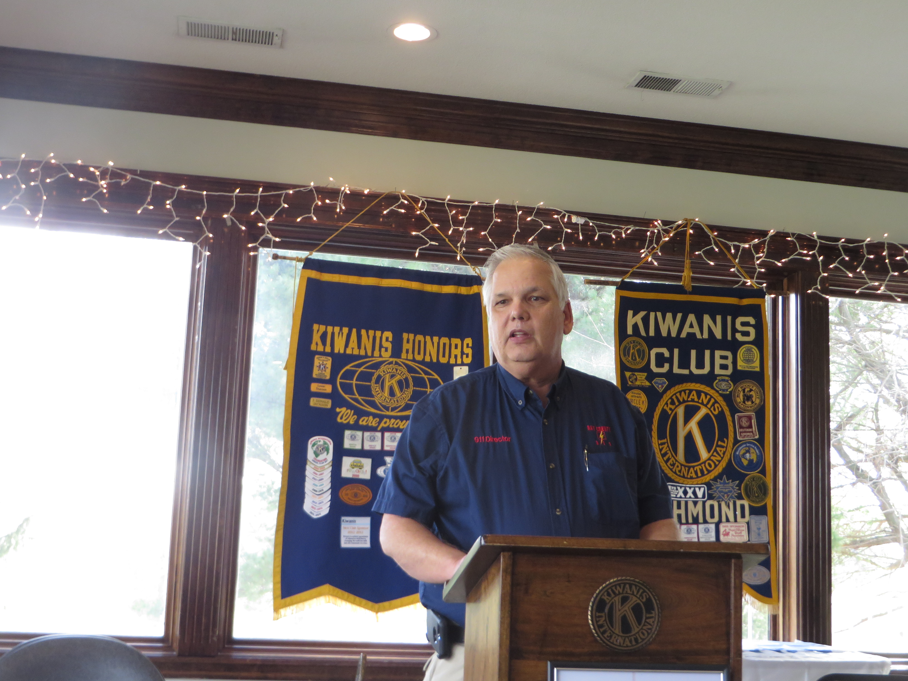
Richard Roark, Executive Director 911

Drawing for the 50/50: Bruce, Brian, and Troy won the money. They donated it back to the club.
Adjournment: 12:45 PM
Barb Dooley Secretary

